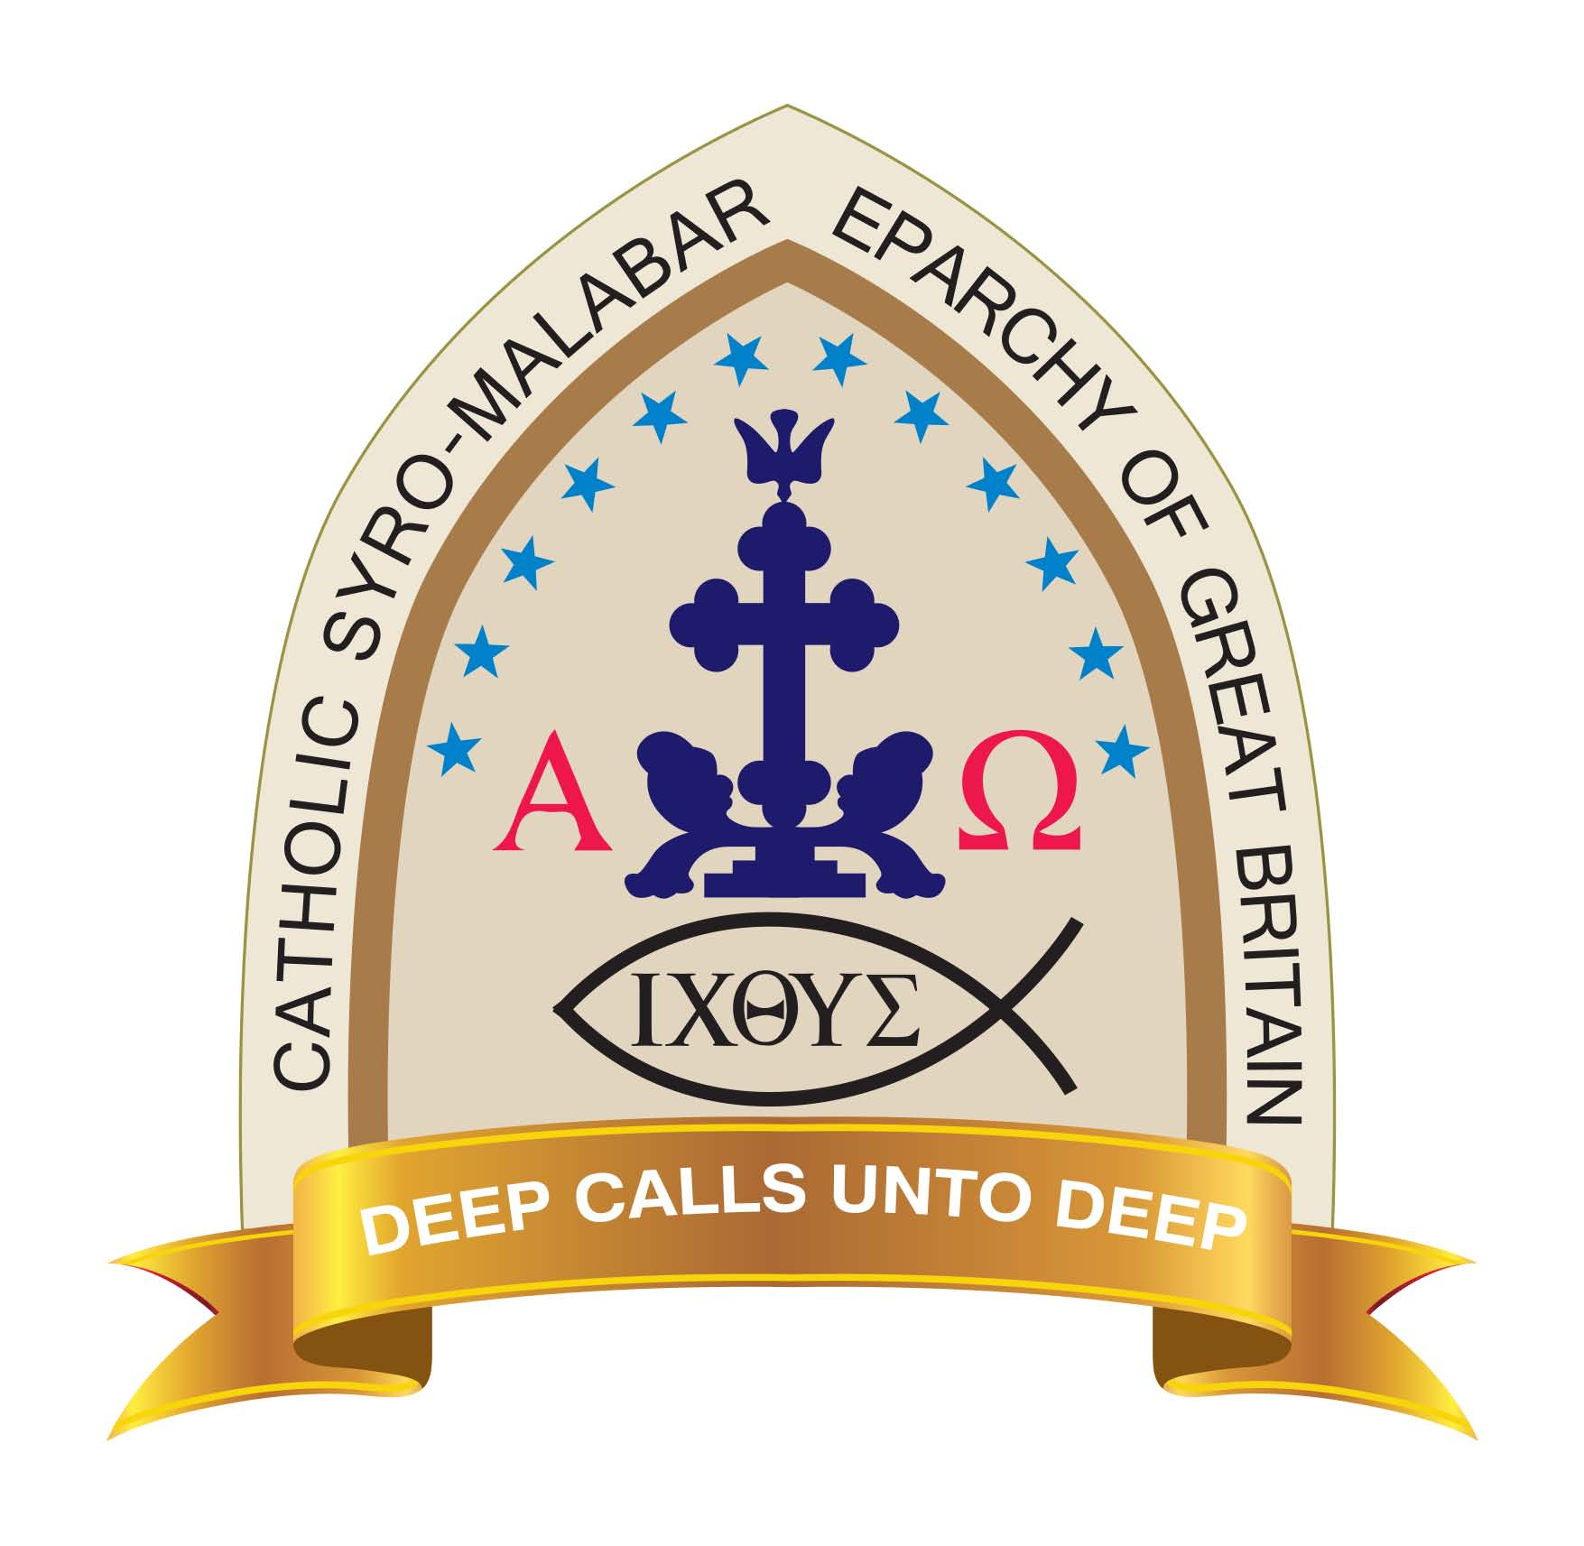
CATHOLIC SYRO-MALABAR EPARCHY OF GREAT BRITAIN
Bishop’s Office, St. Ignatius Square, Preston, Lancashire, United Kingdom, PR1 1TT, Tel: +44 1772 587186
Email:bishop@csmegb.org, Website: www.eparchyofgreatbritain.org Registered Charity Number: 1173537
(FN-013)

PARISH/MISSION/PROPOSED MISSION MEMBER REGISTRATION FORM

Name of the Parish//Mission/Proposed Mission Centre: ST BENEDICT MISSION, SALTLEY
[NOTE: Please fill as much information as possible. If in future any validation of original document is needed, we will need to see the same before we could provide you with any certificate. Please provide the information in BLOCK CAPITALS. Kindly use one form per family. This form should also be used by single individuals. Children aged 13 and above need to sign in the form separately]
No | Title | First Name | Middle Name (Optional) | Surname | Baptismal Name | Relation | Date of Birth | Date of Holy Baptism | Date of Chrismation | Date of Holy Commu nion | Date of Marriage

Postal Address in the UK: |  |  |  |  |  | House Name: |  |  | Town: |  |  |  | City:
 |  |  |  |  |  |  |  |  | Postcode: |  |  |  | E-mail:
 |  |  |  |  |  |  |  |  | Tel No. |  |  |  | Mobile No.
 |  |  | Please Tick [✓] Whichever of the Following Applies:
 |  |  | An Existing Syro-Malabar Catholic Church Member and Updating Information in the UK: |  |  |  |  | If so, Kindly Name the Previous Address Details Below:
 |  |  |  |  |  |  |  | Tel No. ( if any)
 |  |  |  |  |  |  |  | Name of the Parish in India/Previous Place:
 |  |  |  |  |  |  |  | Name of the Diocese/Eparchy in India/Previous Place:
 |  |  | New Member: |  |  |  |  | If so, Other Information you Feel Useful to us:
FORM-013 – CSMEGB – PARISH/MISSION/PROPOSED MISSION MEMBER REGISTRATION FORM – V.1.2

Individual’s Consent Form
Your privacy is important to us and by signing this form; you are confirming that you are explicitly consenting to the Catholic Syro-Malabar Eparchy of Great Britain in holding and processing your personal data/special category data for the following purposes: - (please tick the boxes below where you give consent)

• I consent to the Eparchy in storing/managing/processing my personal data/special category data for the purposes of religious activities organised by the Catholic Syro-Malabar Eparchy of Great Britain, including management of its members’ directory: ⊡
• To share my contact details with the Eparchy’s Regional/Parish/Mission/Proposed Mission centres anywhere within the Eparchy in the UK as part of its activities: ⊡
• ⊡To keep me informed about news, events, activities and services of the Catholic Syro-Malabar Eparchy of Great Britain via POST: ⊡ PHONE: ⊡ E-MAIL: ⊡ SOCIAL MEDIA: ⊡ (You can unsubscribe to this at any time by letting us know in writing by e-mail/post)
• I understand and give consent for photos of myself ⊡ and children ⊡ named above to be displayed in printed form within the church buildings and premises: ⊡
• I understand and give consent for photos of myself ⊡ and children ⊡ named above to be displayed online (e.g. website, social media): ⊡

Confirmation & Declaration: I hereby agree to adhere to the guidelines and regulations of the Catholic Syro-Malabar Eparchy of GB: ⊡
Parents/Individuals/Children (13 & above), Name & Sign Below: DATE: 1. Name & Sign: 5. Name & Sign:
2. Name & Sign: 6. Name & Sign: 3. Name & Sign: 7. Name & Sign: 4. Name & Sign: 8. Name & Sign:
YOUR RIGHTS: Withdrawing Consent: If you change your mind and would like to exercise your individual rights by withdrawing consent, you can do so by contacting the Eparchial office (by e-mail/post) in writing directly or to the respective Parish/Mission/Proposed Mission Centres. However, your rights are not absolute; the Eparchy can withhold some of the information processed as per the UK legislative requirements.
------------------------------------------------------------------------------------------------------------------------------------------------------------------------------------------------THE CATHOLIC SYRO-MALABAR EPARCHY OF GREAT BRITAIN complies with its obligations under GDPR/DPA 2018 by processing data lawfully; keeping personal data up to date; by storing and destroying it securely; by not collecting or retaining excessive amounts of data; by protecting personal data from loss, misuse, unauthorised access and disclosures and by ensuring that appropriate technical measures are in place to protect personal data. For more information on how we use and process your personal data, including for fundraising activities, please read our ‘Privacy Notice’ which can be accessed on our website (http://www.eparchyofgreatbritain.org/ )

FORM-013 – CSMEGB – PARISH/MISSION/PROPOSED MISSION MEMBER REGISTRATION FORM – V.1.2

